Name- Asutosh Banerjee
Superset ID- 6362804
Week- 4
Mandate HandsOn Question 4:-
If id is 1:
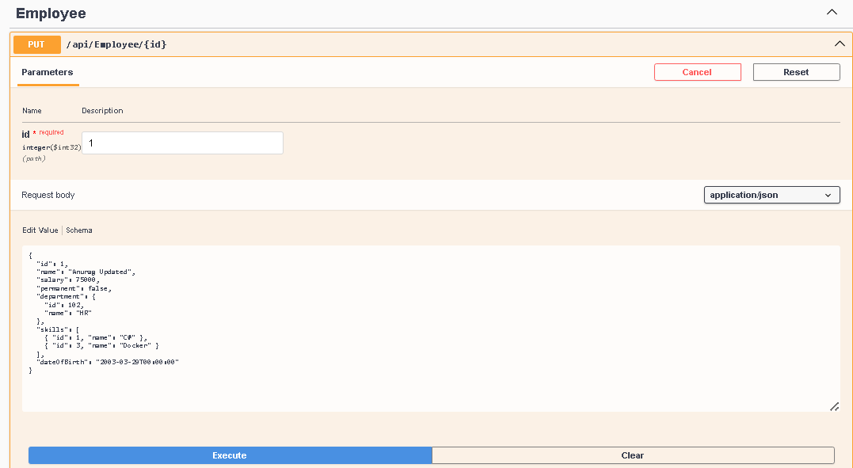
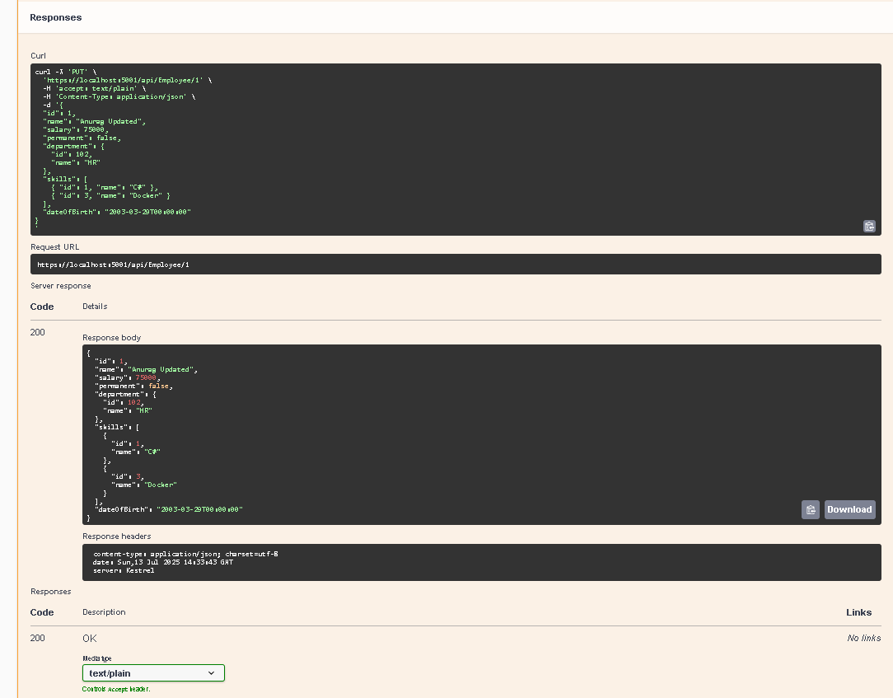

If id is 0:
